**JS TASKS**

**TASK 1**

**function reverseNumber() {**

**// Prompt the user for input**

**const userInput = prompt("Enter a number:");**

**// Convert the user input to a number**

**const num = parseFloat(userInput);**

**// Check if the input is a valid number**

**if (isNaN(num)) {**

**return "Invalid input. Please enter a valid number.";**

**}**

**// Check if the number is negative and store the sign**

**const isNegative = num < 0;**

**// Convert the number to a positive integer**

**const absoluteNum = Math.abs(num);**

**// Convert the number to a string, reverse it, and convert it back to a number**

**const reversedNum = parseInt(absoluteNum.toString().split('').reverse().join(''));**

**// If the original number was negative, make the reversed number negative**

**if (isNegative) {**

**return -reversedNum;**

**} else {**

**return reversedNum;**

**}**

**}**

**// Call the function and display the result**

**const reversed = reverseNumber();**

**console.log(`Reversed Number: ${reversed}`);**

**Task2**

**function sortStringAlphabetically() {**

**// Prompt the user for input**

**const userInput = prompt("Enter a string:");**

**// Check if the user provided a string**

**if (typeof userInput !== 'string' || userInput.length === 0) {**

**return "Invalid input. Please enter a valid string.";**

**}**

**// Convert the string to an array of characters, sort it, and join it back into a string**

**const sortedString = userInput.split('').sort().join('');**

**return sortedString;**

**}**

**// Call the function and display the result**

**const sorted = sortStringAlphabetically();**

**console.log(`Sorted String: ${sorted}`);**

**Task 3**

**<!DOCTYPE html>**

**<html>**

**<head>**

**<title>Calculator</title>**

**<style>**

**#resultBox {**

**border: 1px solid #ccc;**

**padding: 10px;**

**margin-top: 10px;**

**}**

**</style>**

**</head>**

**<body>**

**<h1>Simple Calculator</h1>**

**<!-- Input boxes for user to enter two numbers -->**

**<label for="num1">Enter Number 1: </label>**

**<input type="text" id="num1"><br><br>**

**<label for="num2">Enter Number 2: </label>**

**<input type="text" id="num2"><br><br>**

**<!-- Buttons to perform multiplication and division -->**

**<button id="multiplyButton">Multiply</button>**

**<button id="divideButton">Divide</button><br><br>**

**<!-- Result display area -->**

**<div id="resultBox"></div>**

**<script>**

**// Function to perform multiplication**

**function multiply() {**

**const num1 = parseFloat(document.getElementById('num1').value);**

**const num2 = parseFloat(document.getElementById('num2').value);**

**const resultBox = document.getElementById('resultBox');**

**if (!isNaN(num1) && !isNaN(num2)) {**

**const result = num1 * num2;**

**resultBox.textContent = `The result is: ${result}`;**

**} else {**

**resultBox.textContent = 'Please enter valid numbers.';**

**}**

**}**

**// Function to perform division**

**function divide() {**

**const num1 = parseFloat(document.getElementById('num1').value);**

**const num2 = parseFloat(document.getElementById('num2').value);**

**const resultBox = document.getElementById('resultBox');**

**if (!isNaN(num1) && !isNaN(num2) && num2 !== 0) {**

**const result = num1 / num2;**

**resultBox.textContent = `The result is: ${result}`;**

**} else if (num2 === 0) {**

**resultBox.textContent = 'Cannot divide by zero.';**

**} else {**

**resultBox.textContent = 'Please enter valid numbers.';**

**}**

**}**

**// Attach click event listeners to the buttons**

**document.getElementById('multiplyButton').addEventListener('click', multiply);**

**document.getElementById('divideButton').addEventListener('click', divide);**

**</script>**

**</body>**

**</html>**

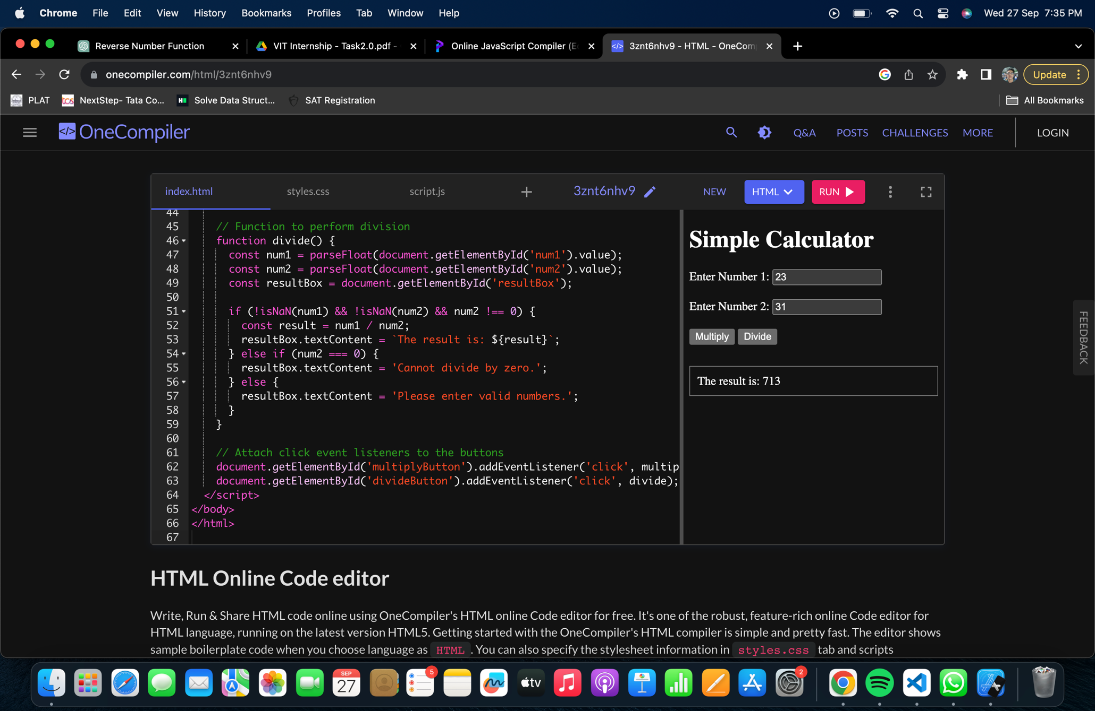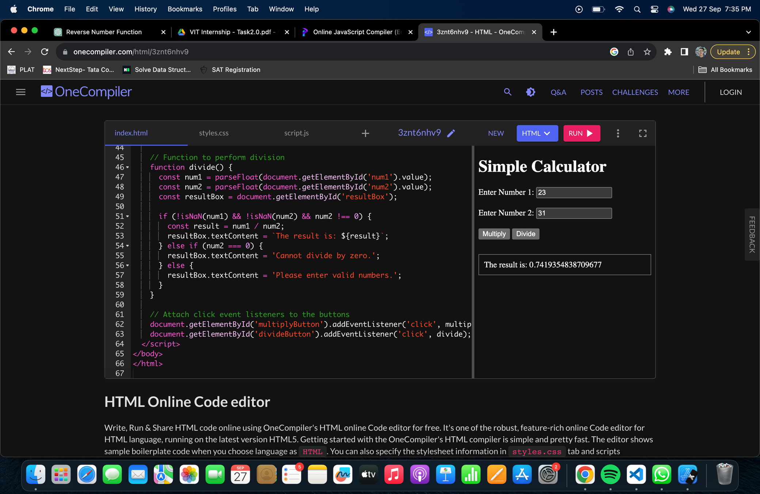

**TASK4**

**<!DOCTYPE html>**

**<html>**

**<head>**

**<title>Date and Time Display</title>**

**<style>**

**#dateButton, #timeButton {**

**background-color: #007BFF;**

**color: white;**

**border: none;**

**padding: 10px 20px;**

**margin: 5px;**

**cursor: pointer;**

**}**

**#result {**

**font-size: 20px;**

**margin-top: 10px;**

**}**

**</style>**

**</head>**

**<body>**

**<h1>Date and Time Display</h1>**

**<!-- Button to display the current date -->**

**<button id="dateButton">Show Date</button>**

**<!-- Button to display the current time -->**

**<button id="timeButton">Show Time</button>**

**<!-- Result display area -->**

**<div id="result"></div>**

**<script>**

**const dateButton = document.getElementById('dateButton');**

**const timeButton = document.getElementById('timeButton');**

**const resultDiv = document.getElementById('result');**

**dateButton.addEventListener('click', () => {**

**const currentDate = new Date();**

**const day = currentDate.getDate();**

**const month = currentDate.toLocaleString('en-US', { month: 'long' });**

**const year = currentDate.getFullYear();**

**const formattedDate = `${day}/${month}/${year}`;**

**resultDiv.textContent = `Current Date: ${formattedDate}`;**

**});**

**timeButton.addEventListener('click', () => {**

**const daysOfWeek = ["Sunday", "Monday", "Tuesday", "Wednesday", "Thursday", "Friday", "Saturday"];**

**const currentTime = new Date();**

**const dayOfWeek = daysOfWeek[currentTime.getDay()];**

**const day = currentTime.getDate();**

**const month = currentTime.toLocaleString('en-US', { month: 'long' });**

**const year = currentTime.getFullYear();**

**const hours = currentTime.getHours();**

**const minutes = currentTime.getMinutes();**

**const seconds = currentTime.getSeconds();**

**const formattedTime = `${dayOfWeek}, ${day} ${month} ${year} ${hours}:${minutes}:${seconds}`;**

**resultDiv.textContent = `Current Time: ${formattedTime}`;**

**});**

**</script>**

**</body>**

**</html>**

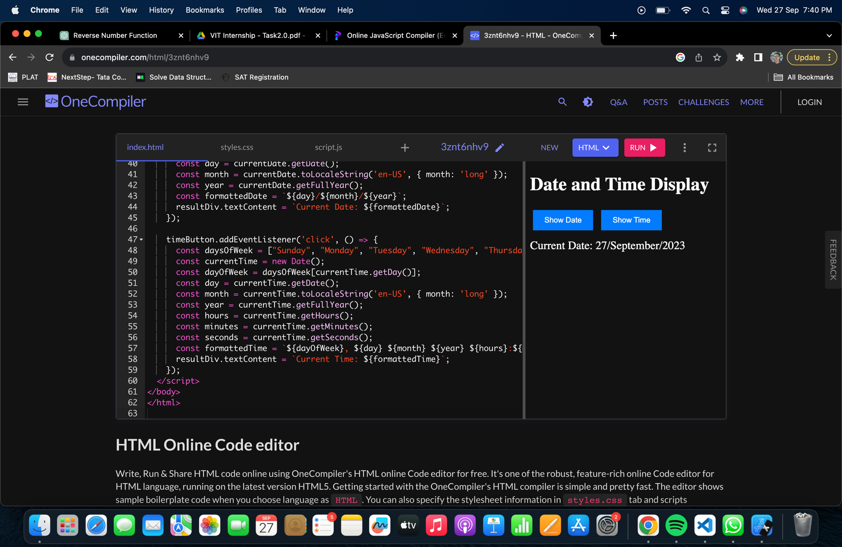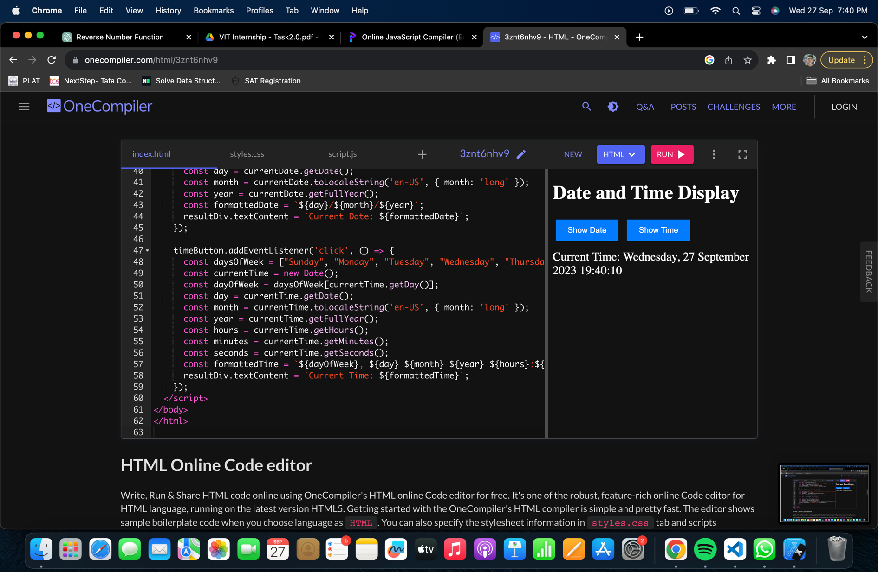

**TASK5**

**<!DOCTYPE html>**

**<html>**

**<head>**

**<title>Form Validation</title>**

**<style>**

**.error {**

**color: red;**

**font-size: 14px;**

**}**

**</style>**

**</head>**

**<body>**

**<h1>Contact Us</h1>**

**<form id="contactForm">**

**<label for="name">Name:</label>**

**<input type="text" id="name" name="name">**

**<span class="error" id="nameError"></span><br><br>**

**<label for="email">Email:</label>**

**<input type="email" id="email" name="email">**

**<span class="error" id="emailError"></span><br><br>**

**<label for="website">Website:</label>**

**<input type="url" id="website" name="website">**

**<span class="error" id="websiteError"></span><br><br>**

**<label for="message">Message:</label>**

**<textarea id="message" name="message"></textarea>**

**<span class="error" id="messageError"></span><br><br>**

**<button type="submit">Submit</button>**

**</form>**

**<script>**

**const contactForm = document.getElementById('contactForm');**

**contactForm.addEventListener('submit', function (e) {**

**let valid = true;**

**const name = document.getElementById('name').value;**

**if (name.trim() === '') {**

**document.getElementById('nameError').textContent = 'Name is required';**

**valid = false;**

**} else {**

**document.getElementById('nameError').textContent = '';**

**}**

**const email = document.getElementById('email').value;**

**if (email.trim() === '') {**

**document.getElementById('emailError').textContent = 'Email is required';**

**valid = false;**

**} else if (!isValidEmail(email)) {**

**document.getElementById('emailError').textContent = 'A valid email is required';**

**valid = false;**

**} else {**

**document.getElementById('emailError').textContent = '';**

**}**

**const website = document.getElementById('website').value;**

**if (website.trim() === '') {**

**document.getElementById('websiteError').textContent = 'Website is required';**

**valid = false;**

**} else if (!isValidURL(website)) {**

**document.getElementById('websiteError').textContent = 'A valid URL is required';**

**valid = false;**

**} else {**

**document.getElementById('websiteError').textContent = '';**

**}**

**const message = document.getElementById('message').value;**

**if (message.trim() === '') {**

**document.getElementById('messageError').textContent = 'Message is required';**

**valid = false;**

**} else {**

**document.getElementById('messageError').textContent = '';**

**}**

**if (!valid) {**

**e.preventDefault();**

**}**

**});**

**function isValidEmail(email) {**

**const emailRegex = /^[^\s@]+@[^\s@]+\.[^\s@]+$/;**

**return emailRegex.test(email);**

**}**

**function isValidURL(url) {**

**try {**

**new URL(url);**

**return true;**

**} catch (error) {**

**return false;**

**}**

**}**

**</script>**

**</body>**

**</html>**

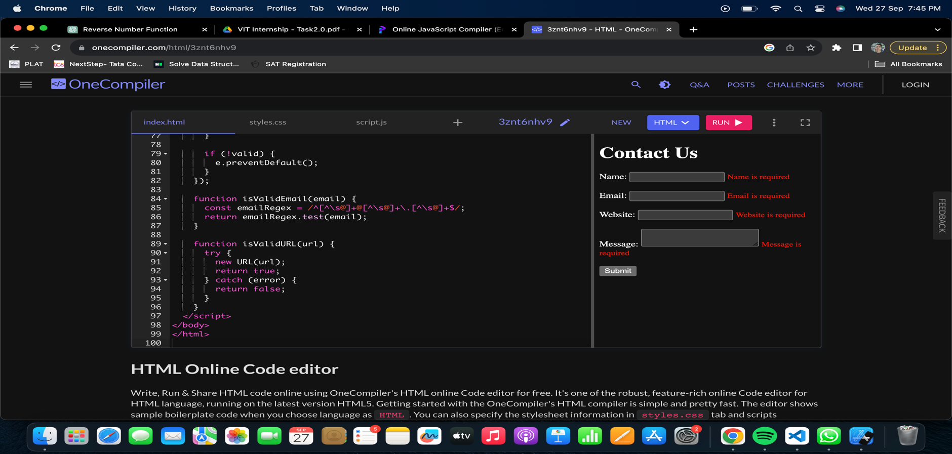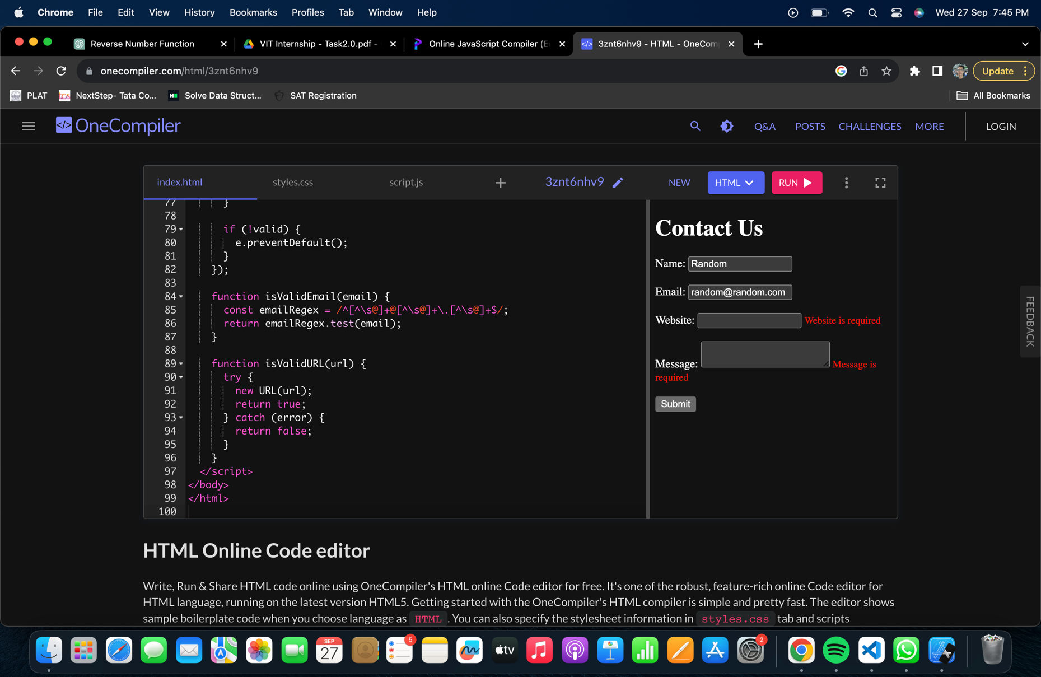

**TASK6**

**<!DOCTYPE html>**

**<html>**

**<head>**

**<title>Login Form</title>**

**<style>**

**body {**

**font-family: "Helvetica Neue", sans-serif;**

**background-color: #f0f0f0;**

**margin: 0;**

**padding: 0;**

**display: flex;**

**justify-content: center;**

**align-items: center;**

**height: 100vh;**

**}**

**.login-container {**

**background-color: #fff;**

**padding: 20px;**

**border-radius: 5px;**

**box-shadow: 0 0 10px rgba(0, 0, 0, 0.1);**

**text-align: center;**

**}**

**.login-container h2 {**

**font-size: 24px;**

**font-family: "Helvetica Neue", sans-serif;**

**}**

**.input-field {**

**margin: 10px 0;**

**padding: 5px;**

**width: 100%;**

**border: 1px solid #ccc;**

**border-radius: 3px;**

**}**

**.checkbox-label {**

**display: inline-block;**

**margin-right: 10px;**

**}**

**.instagram-button {**

**background-color: #007BFF;**

**color: #fff;**

**border: none;**

**padding: 10px 20px;**

**margin-top: 15px;**

**border-radius: 3px;**

**cursor: pointer;**

**font-family: "Helvetica Neue", sans-serif;**

**}**

**.instagram-button:hover {**

**background-color: #0056b3;**

**}**

**.forgot-password {**

**color: #007BFF;**

**text-decoration: none;**

**margin-left: 10px;**

**}**

**.signup-link {**

**color: #007BFF;**

**text-decoration: none;**

**margin-top: 15px;**

**display: block;**

**}**

**</style>**

**</head>**

**<body>**

**<div class="login-container">**

**<h2>Instagram</h2>**

**<input class="input-field" type="text" placeholder="Username">**

**<input class="input-field" type="password" placeholder="Password">**

**<button class="instagram-button">Login</button>**

**<label for="remindMe" class="checkbox-label">Remind me</label>**

**<input type="checkbox" id="remindMe">**

**<a href="#" class="forgot-password">Forgot Password</a>**

**<a href="#" class="signup-link">Don't have an account? Sign up</a>**

**</div>**

**</body>**

**</html>**

